Table of Contents
Chapter One : General Introduction 6
1.0 Introduction 6
1.1 Subject and Field of Study 7
1.2 Study Objectives 8
1.2.1 General Objective 8
1.2.2 Specific Objectives 8
1.3 Background Study 9
1.4 Scope of Study 11
1.5 Justification of the Study/Significance of Study 13
1.6 Methodology 15
Data Collection Methods: 15
1.7 Expected Results of the Study & Possible Use (Research/Study Deliverables) 19
Primary Deliverables: 19
Expected Outcomes and Impact: 20
Possible Uses and Applications: 21
1.8 Presentation of Thesis (Chapter-by-Chapter Summary of Thesis) 22
1.9 Study Work Plan (Timelines) 25
Phase 1: Research Planning and Preparation (Months 1-2) 25
Phase 2: Literature Review and Data Collection (Months 3-4) 25
Phase 3: Analysis and System Requirements (Months 5-6) 26
Phase 4: System Design (Months 7-8) 26
Phase 5: System Implementation (Months 9-10) 26
Phase 6: Testing, Documentation, and Finalization (Months 11-12) 27
Chapter 2: Literature Review 28
2.0 Introduction 28
2.1 Theoretical Foundations of Scheduling Systems 28
2.1.1 Operations Research and Constraint Satisfaction 28
2.1.2 Time Management Theory and Cognitive Psychology 30
2.2 Evolution and Current State of Educational Timetabling Systems 31
2.2.1 Historical Development 31
2.2.2 Current Challenges in Educational Timetabling 33
2.2.3 Recent Algorithmic Advancements 34
2.3 Personal Time Management Tools: Advancements and Limitations 35
2.3.1 Evolution of Digital Time Management 35
2.3.2 Current Limitations in Personal Scheduling Tools 36
2.4 AI Applications in Scheduling: Techniques and Approaches 37
2.4.1 Machine Learning for Pattern Recognition and Prediction 37
2.4.2 Natural Language Processing for Interface Enhancement 38
2.4.3 Adaptive and Learning Systems 39
2.5 Integration Challenges Between Institutional and Personal Scheduling 40
2.5.1 Technical Integration Challenges 40
2.5.2 Conceptual and Preference Integration 41
2.6 Analysis of Existing AI-Enhanced Timetabling Systems 42
2.6.1 System 1: UniTime Scheduling System 42
Architecture and Approach 43
Critical Evaluation 43
2.6.2 System 2: Neural Network-Based University Course Timetabling System 44
Architecture and Approach 45
Critical Evaluation 46
2.6.3 System 3: Microsoft Scheduler 47
Architecture and Approach 47
Critical Evaluation 47
2.6.4 System 4: Google Calendar 48
Architecture and Approach 48
Critical Evaluation 49
2.6.5 System 5: Outlook Calendar 51
Architecture and Approach 51
Critical Evaluation 52
2.6.6 System 6: Mimosa Scheduling 53
Architecture and Approach 53
Critical Evaluation 54
2.6.7 System 7: Celcat Timetabler 55
Architecture and Approach 55
Critical Evaluation 56
2.6.8 System 8: Asana 58
Architecture and Approach 58
Critical Evaluation 59
2.6.9 System 9: Todoist 60
Architecture and Approach 60
Critical Evaluation 61
2.6.10 System 10: Any.do 62
Architecture and Approach 62
Critical Evaluation 63
2.7 Research Gaps and Opportunities 65
2.7.1 Integration Gap 65
2.7.2 Adaptability Limitations 65
2.7.3 User Experience Challenges 66
2.7.4 Limited Learning Capabilities 66
2.7.5 Personalization Opportunities 66
2.7.6 Implementation Frameworks 67
2.8 Conclusion 67
3.0 Crystallization of the Problem 71
3.1 System 1 : UniTime Scheduling System 72
3.1.1 Background/History 72
3.1.2 How They Operate 73
3.1.3 Strengths/Advantages and Weaknesses/Disadvantages 74
Strengths/Advantages 74
Weaknesses/Disadvantages 75
3.2 System 2 : Neural Network-Based University Course Timetabling System 79
3.2.1 Background/History 79
How They Operate 79
Data Flow Diagram 83
Strengths / Advantages 83
Weaknesses / Disadvantages 84
Chapter 4: Analysis of the Proposed System 86
4.0 Overview of the Proposed System 86
Non-functional Requirements 90
4.1 Major Features and Components of the Proposed System 91
4.2 Benefits and Advantages of the Proposed System 93
4.3 System Context Diagram of the Proposed System 97

VALLEY VIEW UNIVERSITY

FACULTY OF SCIENCE

DEPARTMENT OF COMPUTER SCIENCE

A THESIS SUBMITTED IN PARTIAL FULFILLMENT OF.THE BACHELOR OF SCIENCE DEGREE (BSc.) IN COMPUTER SCIENCE

PROPOSED TOPIC:
AI-POWERED SCHEDULING SYSTEM: INVESTIGATING THE APPLICATIONS AND BENEFITS OF AI-POWERED SCHEDULING SYSTEMS IN EDUCATIONAL INSTITUTIONS AND PERSONAL TIME MANAGEMENT

BY:
OLADIPUPO ABEEB OLANREWAJU

ID:
223CS01000941

Supervisor : Mr. Ezekiel Okoe

Date : November,2025

DECLARATION
This is to declare that, the research work underlying this thesis
has been carried out by the under mentioned student under the
supervisor. Both student and the supervisor certify that the
work documented in this thesis is the output of the research
conducted by the student as part of the final year project work
in partial fulfillment of the requirement of the Bachelor of
Science in Computer Science degree.

STUDENT : SUPERVISOR:
Oladipupo Abeeb Olanrewaju Mr. Ezekiel Okoe

------------------------ -----------------
SIGNATURE SIGNATURE
DATE: DATE:

Chapter One : General Introduction

1.0 Introduction
Time management represents one of the challenges that both educational institutions and personal life. Educational institutions face the complex task of scheduling classes, allocating resources, and coordinating various stakeholders' activities efficiently(Ghiani, 2021). Individuals also have issues with effectively managing their time amidst personal and professional activities(Carvalho, 2023). Traditional methods of timetabling, at times, result in inefficient resource utilization, schedule conflicts, and adaptation limitations. Artificial Intelligence (AI) offers promising solutions to these challenges through automation and optimization techniques(Agarwal, 2023).

This research examines how AI-powered timetable systems can be used to upgrade scheduling processes in both educational settings and personal time management. The integration of machine learning algorithms, predictive analytics, and natural language processing capabilities will allow the proposed system to analyze patterns, predict resource requirements, optimize schedules, and adapt to unforeseen circumstances(Feng, 2022).
This integration helps to address the time management needs of individuals who want to navigate both institutional and personal scheduling requirements.This research aims to bridge this gap by developing a comprehensive AI-powered timetabling solution that serves both domains effectively.

1.1 Subject and Field of Study
This research falls within the intersection of several fields, mainly:
- Computer Science: primarily focusing on artificial intelligence, machine learning, and software development methodologies for creating the proposed system.
- Educational Technology: Examining technology that can enhance administration and resource management within academic institutions.
- Operations Research: applying optimization techniques for solving complex scheduling problems and resource allocation problems through mathematics(Okagbue, 2023).
- Time Management Psychology: Understanding how time utilization and scheduling can be used for developing effective personal scheduling tools.
The primary subject of this study is the application of AI technologies or algorithms in developing an integrated timetabling system that serves educational and personal time requirements. This approach bridges the gap between educational efficiency and individual productivity.

1.2 Study Objectives

The study objectives are composed of a general objective and a specific objective, which are expounded as follows:

1.2.1 General Objective
The global objective is to develop and implement an AI-powered system that effectively addresses the scheduling needs of educational institutions and individuals. This proposed system will demonstrate its advantages over traditional timetabling methods and existing systems in the aspect of efficiency, adaptability, and user satisfaction.

1.2.2 Specific Objectives
1. To analyze existing timetabling systems in educational institutions and identify key limitations and challenges that affect scheduling efficiency.
2. To examine current personal time management tools and determine gaps in functionality that could be addressed through AI integration.
3. To identify and analyze the requirements for an integrated timetabling system that serves both educational institutions and individual users.
4. To implement and test the proposed system in educational settings and with individual users to evaluate its effectiveness in addressing scheduling challenges
5. To assess improvements in scheduling efficiency, resource utilization, user satisfaction, and adaptability compared to traditional timetabling methods
6. To design and develop an AI-powered timetabling system incorporating machine learning algorithms for pattern recognition, predictive analytics for resource allocation, and adaptive scheduling capabilities.

1.3 Background Study

Timetabling has been a persistent challenge in educational institutions since their inception. Traditionally, educational timetabling was a manual process conducted by administrators who allocated resources based on predefined criteria and personal judgment. This process was labor-intensive, time-consuming, and prone to errors and inefficiencies. With the growth in educational institutions' size and complexity, these challenges have multiplied, making manual timetabling increasingly impractical.

The first wave of computerization in educational timetabling began in the 1960s and 1970s with basic scheduling software that automated some aspects of the process. However, these early systems lacked sophistication and flexibility, often requiring significant manual intervention and adjustment(Burke, 2022). The 1980s and 1990s saw the emergence of more advanced algorithmic approaches, including constraint-based programming and heuristic methods, which improved the quality of automatically generated schedules.
Over the years, educational timetabling systems have generally operated separately from personal scheduling tools. While personal time management has evolved from paper planners to more advanced digital applications, these tools often don’t connect with institutional scheduling systems. This disconnect can make it challenging for users to organize their time effectively across different areas of their lives.

In the last decade, we've seen remarkable progress in artificial intelligence and machine learning, paving the way for smarter scheduling solutions. AI technologies bring a range of abilities like recognizing patterns, predicting future needs, processing natural language, and learning over time(Hartono, 2023). These capabilities can significantly enhance how we manage schedules by learning from past data, adapting to new situations, and optimizing timetables based on various criteria.

Recent studies have highlighted the benefits of using AI in educational timetabling, showing improvements in how resources are used, resolving conflicts, and making scheduling more efficient. Similarly, AI has begun to transform personal productivity tools, offering personalized recommendations and helping people manage their time in a more effective way.

However, there’s still a noticeable gap between educational scheduling and personal time management. This research aims to create an AI-powered timetable system that integrates both areas. By doing so, we hope to provide a comprehensive solution to the scheduling challenges faced by educational institutions and individuals alike.

1.4 Scope of Study
This research encompasses the development and implementation of an AI-powered timetable system with applications in both educational institutions and personal time management. The scope of this study includes:
Geographical Scope: The research will be conducted at Valley View University as the primary educational institution case study. Additional data will be collected from a sample of individual users, including students, faculty members, and administrative staff from the institution, to assess personal time management needs.
Technical Scope: The study will focus on the following technical aspects:
- AI algorithms for pattern recognition and predictive analytics in scheduling
- Machine learning models for adaptive scheduling and personalization(Rahman, 2022)
- System architecture for integrating educational and personal scheduling components
- User interface design for different user categories
- Database design and implementation for efficient data management
- Security and privacy considerations for protecting sensitive scheduling data
- Cross-platform compatibility for accessibility across devices
Functional Scope: The proposed system will include the following key functionalities:
- Educational timetable generation for courses, rooms, and resources
- Faculty and staff scheduling management
- Student class scheduling and timetable access
- Personal appointment and task scheduling
- Integration between institutional and personal schedules (Gayathri, 2024)
- Conflict detection and resolution
- Resource optimization and allocation
- Notification and reminder system
- Analytics and reporting capabilities
- User preference learning and adaptation (Rahman, 2022)

1.5 Justification of the Study/Significance of Study
This research is justified by several compelling factors that highlight its importance and potential impact:
Educational Administrative Efficiency: Educational institutions face increasingly complex scheduling challenges as they grow in size and diversity of offerings. Traditional timetabling processes consume significant administrative resources. An AI-powered system could significantly reduce this burden, allowing administrators to focus on strategic educational priorities
Resource Optimization: Inefficient scheduling leads to under-utilization of physical resources such as classrooms, laboratories, and equipment. AI-powered timetabling can optimize resource allocation, potentially resulting in improved cost savings and improved resource utilization.
Student and Faculty Satisfaction: Scheduling conflicts and inefficient timetables negatively impact student and faculty satisfaction and productivity. A well-designed timetabling system directly contributes to the overall quality of the educational experience.
Personal Productivity Enhancement: Individual time management challenges are universal. AI-powered personal scheduling tools can help individuals optimize their time use, potentially increasing productivity according to productivity research studies(Kumar, 2023).
Integration of Institutional and Personal Schedules: The disconnect between educational and personal scheduling systems creates inefficiencies and conflicts for individuals navigating both domains(Gayathri, 2024).
Technological Innovation: This research contributes to the field of AI applications in educational technology and personal productivity tools, advancing understanding of how machine learning algorithms can be effectively applied to complex scheduling problems.
Economic Impact: Improved scheduling efficiency translates to economic benefits through better resource utilization, reduced administrative costs, and enhanced productivity.
Adaptability to Change: The COVID-19 pandemic highlighted the importance of flexible and adaptive scheduling systems in educational institutions. AI-powered systems that will quickly respond to changing circumstances and requirements represent a significant advantage in uncertain environments.
This research addresses a practical problem with widespread implications for educational institutions and individuals, offering a technologically advanced solution with potential for significant positive impact on efficiency, productivity, and satisfaction(Agarwal, 2023).

1.6 Methodology
This research employs a comprehensive methodology combining various approaches to ensure thorough analysis, effective system development, and rigorous evaluation. The methodology encompasses both research components and system development processes.
Research Approach: The study adopts a mixed-method approach combining quantitative and qualitative research techniques to gather comprehensive data on timetabling needs, challenges, and requirements. This approach provides statistical insights and deep understanding of user experiences and contexts.

Data Collection Methods:
- Literature Review: A systematic review of academic publications, industry reports, and technical documentation related to AI applications in scheduling, educational timetabling systems, and personal time management tools will be conducted. This will establish the theoretical foundation and identify existing gaps in research and practice(Ghiani, 2021).
- Questionnaires: Structured questionnaires will be distributed to a broader sample of potential users to collect quantitative data on:
  - Satisfaction with current timetabling systems
  - Common scheduling challenges and pain points
  - Feature preferences and priorities
  - Technology adoption factors
  - Integration needs between educational and personal scheduling
- Observation: Direct observation of current timetabling processes in educational settings will be conducted to understand workflow patterns, bottlenecks, and operational contexts. This will inform the design of more effective system processes.
Software Development Methodology: This research will employ the Agile software development methodology, specifically the Scrum framework, for developing the AI-powered timetable system. The choice of Agile methodology is justified by the following factors:
- Iterative and Incremental Development: Agile's iterative approach allows for progressive refinement of the AI algorithms and system features based on continuous feedback, which is essential for developing an effective learning system.
- User-Centered Design: The Scrum framework emphasizes continuous stakeholder involvement and feedback, ensuring that the system addresses actual user needs rather than assumed requirements.
- Flexibility and Adaptability: AI system development often involves unexpected challenges and discoveries. Agile's flexible approach allows for adaptation to new insights and changing requirements during the development process.
- Frequent Deliverables: Regular sprints produce working increments of the system that can be tested and evaluated, providing early validation of concepts and approaches.
- Risk Mitigation: Early and continuous testing in Agile development helps identify and address technical and functional risks before they become significant obstacles.
Development Process: The system development will follow these key phases within the Agile framework:
- Requirements Gathering and Analysis: Collection and analysis of user requirements through interviews, questionnaires, and observations, resulting in user stories and system requirements specification.
- System Architecture Design: Development of high-level system architecture including AI components, database design, user interface mock-ups, and integration specifications.
- Sprint Planning and Execution: Organization of development work into 2-week sprints, each delivering specific system features and components. Sprint planning will prioritize features based on user value and technical dependencies.
- AI Model Training and Testing: Development, training, and validation of machine learning models using historical scheduling data and synthetic datasets for pattern recognition and predictive capabilities(Hartono, 2023). Iterative Development and Testing: Progressive development of system components with continuous integration and testing, including unit tests, integration tests, and user acceptance testing.
- Deployment and Evaluation: Implementation of the system in the case study environment with an understandable evaluation against predefined performance metrics and user satisfaction criteria.
This methodology ensures a systematic approach to both research and system development components of the study, with emphasis on user involvement, empirical validation, and iterative improvement throughout the process.

1.7 Expected Results of the Study & Possible Use (Research/Study Deliverables)

This research is expected to yield several important deliverables and outcomes that will contribute to both academic knowledge and practical applications in AI-powered scheduling. The anticipated results include:

Primary Deliverables:
- AI-Powered Timetable System: A fully functional software system incorporating AI capabilities for educational institution timetabling and personal scheduling.
- Comprehensive Research Report: A detailed documentation of the research process, findings, system development, and evaluation results, providing valuable insights for academic understanding and future development in AI-powered scheduling systems.
- Empirical Data: Collection and analysis of empirical data on timetabling efficiency, resource utilization, user satisfaction, and system performance, establishing benchmarks for future research and development in this field.
- AI Models and Algorithms: Specialized machine learning models and algorithms for scheduling optimization, pattern recognition, and predictive analytics that can be adapted for similar applications in other contexts ((Hartono, 2023)&(Rahman, 2022)).

Expected Outcomes and Impact:
- Educational Institution Benefits:
  - Reduction in administrative time spent on timetabling
  - Improvement in resource utilization through optimized scheduling.
  - Decrease in scheduling conflicts by at least 50% compared to traditional methods
  - Enhanced ability to adapt to changing requirements and constraints
  - Improved faculty and student satisfaction with scheduling processes
- Personal User Benefits:
  - Reduction in time spent on schedule management by 30-40% (Kumar, 2023)
  - Improved time allocation aligned with personal priorities and goals
  - Better integration between institutional and personal commitments(Gayathri, 2024).
  - Enhanced productivity through optimized scheduling suggestions
  - Reduced scheduling conflicts and missed appointments

Possible Uses and Applications:
- Educational Institutions:
  - Implementation in universities, colleges, and schools for academic scheduling(Burke, 2022).
  - Resource management optimization for classrooms, laboratories, and equipment
  - Faculty workload distribution and teaching schedule optimization
  - Special events and examination scheduling
- Individual Professional Use:
  - Personal productivity enhancement through AI-powered scheduling suggestions
  - Work-life balance improvement through intelligent time allocation
  - Integration of professional and personal commitments
  - Habit formation and goal achievement through optimized scheduling
- Commercial Applications:
  - Potential commercialization as a SaaS (Software as a Service) product
  - Integration possibilities with existing educational management systems
  - Licensing opportunities for the AI algorithms and models
  - Consulting services for implementing similar systems in various institutions
These expected results and deliverables represent significant contributions to both the theoretical understanding and practical application of AI technologies in scheduling and time management domains.

1.8 Presentation of Thesis (Chapter-by-Chapter Summary of Thesis)

This thesis is structured into eight comprehensive chapters that systematically address the research objectives and system development process:
Chapter 1: General Introduction This chapter introduces the research topic, establishes the subject and field of study, outlines the objectives, provides background context, defines the scope, justifies the significance, describes the methodology, outlines expected results, and presents the thesis structure. It lays the foundation for understanding the research purpose and approach.
Chapter 2: Literature Review A critical examination of existing literature related to AI applications in scheduling, educational timetabling systems, personal time management tools, and integration approaches(Ghiani, 2021). This chapter analyzes theoretical frameworks, evolutionary trends, technological approaches and identifies research gaps that this study aims to address. It also includes detailed reviews of at least two existing AI timetable systems.
Chapter 3: Crystallization of the Problem :This chapter provides an in-depth analysis of the current timetabling systems and personal scheduling methods used by individuals (It includes system context diagrams, process flow diagrams, data flow diagrams, and a comprehensive analysis of strengths and weaknesses of existing approaches. User pain points and requirements are identified through stakeholder analysis.
Chapter 4: Analysis of the Proposed System A detailed analysis of the proposed AI-powered timetable system, including functional and non-functional requirements. This chapter outlines the major features and components of the system, elaborates on the benefits and advantages over current approaches, and presents the system context diagram illustrating the interactions between system components and external entities.
Chapter 5: Detailed Design of the Proposed System This chapter presents the technical design of the system, including functional processes, algorithms and flowcharts(Hartono, 2023), data flow diagrams, data dictionary, entity relationship diagrams, use cases, and UML class diagrams. It provides a comprehensive blueprint for the system implementation, detailing the technical architecture and component interactions.
Chapter 6: System Implementation and Testing A description of the system implementation process including hardware and software requirements, development environment, implementation architecture, and component implementation details. This chapter also covers the testing strategy, test cases, and results of various testing phases, including unit testing, integration testing, system testing, user acceptance testing, performance testing, and security testing.
Chapter 7: System Documentation Comprehensive documentation for system users, including installation guides, configuration instructions, and user manuals tailored to different user categories. This chapter provides detailed instructions for system setup, operation, and troubleshooting to facilitate effective implementation and use.
Chapter 8: Conclusion and Recommendations The final chapter summarizes the research findings, evaluates the achievement of objectives, acknowledges limitations, presents conclusions, offers recommendations for different stakeholders, and suggests directions for future research. It synthesizes the insights gained throughout the research and development process.
Each chapter builds on the preceding content to create a cohesive narrative of the research and development process, from problem identification to solution implementation and evaluation.

1.9 Study Work Plan (Timelines)
This research project will be conducted over a period of 12 months, divided into systematic phases to ensure timely completion of all objectives. The timeline below outlines the major activities and their expected duration:

Phase 1: Research Planning and Preparation (Months 1-2)
• Week 1-2: Problem definition and research proposal development
• Week 3-4: Literature review planning and preliminary research(Ghiani, 2021).
• Week 5-6: Research methodology design and planning
• Week 7-8: Development of data collection instruments (questionnaires)

Phase 2: Literature Review and Data Collection (Months 3-4)
• Week 9-12: Comprehensive literature review ((Kumar, 2023)&(Burke, 2022).
• Week 13-15: Instrument validation and pilot testing.
• Week 16-18: Questionnaire distribution and collection.

Phase 3: Analysis and System Requirements (Months 5-6)
• Week 19-21: Data analysis and interpretation.
• Week 22-24: System requirements specification
• Week 25-26: System architecture design

Phase 4: System Design (Months 7-8)
• Week 27-28: Database design and modeling
• Week 29-30: AI algorithm design and initial modeling (Rahman, 2022)
• Week 31-32: User interface design and prototyping
• Week 33-34: System integration planning

Phase 5: System Implementation (Months 9-10)
• Week 35-36: Database implementation
• Week 37-38: AI component development and training (Hartono, 2023)
• Week 39-40: User interface implementation
• Week 41-42: System integration and initial testing

Phase 6: Testing, Documentation, and Finalization (Months 11-12)
• Week 43-44: Comprehensive system testing
• Week 45-46: User acceptance testing and feedback collection
• Week 47-48: System refinement based on feedback
• Week 49-50: System documentation and user manual development
• Week 51-52: Thesis compilation, review, and submission
This timeline includes buffer periods to accommodate potential delays and allows for iterative development cycles consistent with the Agile methodology. Regular progress reviews and milestone assessments will be conducted to ensure adherence to the timeline and quality standards.

Chapter 2: Literature Review

2.0 Introduction
This chapter provides a critical and in-depth review of existing literature on AI-powered timetabling systems for educational institutions and personal time management. The purpose of this review is to summarize, synthesize, and analyze the arguments of others to establish a foundation for the current research. By examining relevant theoretical frameworks, technological approaches, implementation strategies, and existing systems, this review identifies knowledge gaps that the present study aims to address.
The literature review is organized into five main sections: theoretical foundations of scheduling systems, evolution of educational timetabling approaches, advancements in personal time management tools, AI applications in scheduling systems, and integration challenges between institutional and personal scheduling. The chapter concludes with an in-depth analysis of two existing AI-enhanced timetabling systems, highlighting their methodologies, strengths, and limitations.

2.1 Theoretical Foundations of Scheduling Systems

2.1.1 Operations Research and Constraint Satisfaction

Scheduling problems fundamentally represent a subset of operations research, involving the allocation of resources over time while satisfying various constraints. According to Ghiani and Ronzino (2021), educational timetabling specifically belongs to the class of constraint satisfaction problems (CSPs), which are mathematically complex and typically NP-hard.
Their systematic review identified several theoretical approaches to timetabling, including:
- Graph coloring methods
- Integer linear programming
- Constraint logic programming
- Meta-heuristic approaches
Okagbue and Adamu (2023) further develop the mathematical foundations for educational timetabling. They distinguish between hard constraints (requirements that must be satisfied for a solution to be feasible) and soft constraints (preferences that should be optimized but can be compromised if necessary). Their work demonstrates that the mathematical complexity of educational timetabling stems not only from the number of variables but also from the hierarchical and sometimes conflicting nature of constraints. They argue that "traditional mathematical programming approaches often struggle with the dynamic nature of educational environments, where constraints may change unexpectedly" (p. 177), highlighting a key limitation that AI approaches might address.
Analyzing these theoretical foundations reveals that while constraint satisfaction and operations research provide robust mathematical frameworks for timetabling, they often fail to account for the human and organizational factors that influence scheduling decisions in the process. This represents a significant gap in the theoretical literature that the current study aims to address through the integration of AI capabilities that can learn from and adapt to human preferences and organizational patterns.

2.1.2 Time Management Theory and Cognitive Psychology
In the domain of personal scheduling, time management theory provides important psychological and behavioral foundations Kumar and Mehta (2023) note that effective personal time management typically involves four key processes:
- Goal setting and prioritization
- Planning and scheduling
- Execution and time monitoring
- Adaptation and optimization
Their research demonstrates that "technological interventions in time management are most effective when they align with these natural cognitive processes rather than imposing artificial structures" (p. 231). This finding suggests that AI systems for personal scheduling should augment rather than replace human decision-making processes.
Carvalho and Santos (2023) gave more perspective by examining the cognitive load associated with different time management approaches. Their systematic literature review reveals that digital tools can simultaneously reduce certain cognitive burdens (by automating reminders and calculations) while introducing new ones (through complex interfaces or excessive notifications). They argue that "the cognitive overhead of managing the tool itself must be significantly less than the cognitive benefits it provides" (p. 7) for sustained user adoption.
This analysis points out a significant flaw in our current time management systems: they often ignore the cognitive and psychological aspects that affect how we schedule our time. Instead, they focus solely on functional features. This research aims to address that gap by developing an AI-powered system designed to align with our natural thinking and processing styles. The goal is to ease our mental burdens rather than add to them, helping us manage our time in a way that feels more intuitive and supportive.

2.2 Evolution and Current State of Educational Timetabling Systems

2.2.1 Historical Development
Burke and Petrovic (2022) provide a historical perspective on the evolution of automated academic timetabling, tracing its development from early manual approaches through various computational methods. They identify distinct phases in this evolution:
- Manual Era (pre-1960s): Characterized by entirely manual processes requiring significant administrative effort and limited optimization capability.
- Early Automation (1960s-1970s): Introduction of basic computerized systems that primarily focused on recording and organizing information rather than optimization.
- Algorithm Development (1980s-1990s): Emergence of specialized algorithms including graph coloring, simulated annealing, tabu search, and genetic algorithms.
- Hybrid and Meta-heuristic Approaches (2000s-2010s): Development of more sophisticated techniques combining multiple algorithms and incorporating meta-heuristic approaches to handle complex constraint sets.
- AI Integration (2010s-present): Beginning of AI integration through machine learning techniques, pattern recognition, and adaptive systems.
Their analysis reveals that while significant progress has been made in computational efficiency and solution quality, "many institutions still rely on outdated approaches that fail to leverage recent technological advances" (p. 3). This observation highlights a gap between theoretical advances and practical implementation that the current research aims to address.

2.2.2 Current Challenges in Educational Timetabling
Agarwal and Mehta (2023) provide a comprehensive review of AI-driven scheduling systems in education, identifying several persistent challenges in current approaches:
- Scalability Issues: Many existing systems struggle to maintain performance as the size and complexity of the institution increase.
- Adaptation Limitations: Current systems typically require complete rescheduling when constraints change, lacking the ability to adapt incrementally to new conditions.
- User Interface Complexity: Administrative interfaces often require specialized training, limiting widespread adoption and utilization.
- Integration Deficiencies: Most systems operate in isolation from other institutional systems and personal scheduling tools.
- Limited Learning Capabilities: Few systems incorporate capabilities to learn from past scheduling decisions and outcomes.
Their critical review concludes that "despite advances in AI technology, educational timetabling systems have not fully leveraged these capabilities to address fundamental challenges" (p. 153). This assessment aligns with Burke and Petrovic's (2022) observation that there exists a significant gap between theoretical advancements and practical implementation in educational institutions.

2.2.3 Recent Algorithmic Advancements
Recent research has explored more sophisticated algorithmic approaches to educational timetabling. Hartono and Hashimoto (2023) demonstrate the application of neural networks to university course timetabling, showing that deep learning approaches can identify patterns and relationships that traditional algorithms might miss. Their experimental results indicate a 23% improvement in schedule optimization compared to conventional methods, suggesting significant potential for neural network approaches.
Similarly, Feng et al. (2022) explore reinforcement learning for dynamic timetable generation, demonstrating how this approach enables systems to adapt to changing constraints and learn from outcomes. Their case study in a university setting showed that "reinforcement learning models were able to reduce scheduling conflicts by 37% compared to traditional methods while improving resource utilization by 28%" (p. 302). These findings suggest that adaptive AI techniques may address some of the limitations of conventional approaches.
Taking a closer look at these algorithmic advancements shows that, although they often show exciting improvements when tested in labs, many of them haven't made it into large-scale real-world use yet. This gap between the innovative prototypes developed in research and the practical systems that could benefit from them is a key issue that this study seeks to tackle by focusing on a thorough implementation strategy.

2.3 Personal Time Management Tools: Advancements and Limitations

2.3.1 Evolution of Digital Time Management
Carvalho and Santos (2023) trace the evolution of personal time management applications from basic digital calendars to sophisticated productivity tools. Their systematic review identifies a trend toward increasing functionality but questions whether this has resulted in proportional productivity improvements. They observe that "feature proliferation often comes at the cost of usability, potentially undermining the primary goal of reducing cognitive load in time management" (p. 4). This critical observation suggests that technological sophistication does not necessarily translate to improved user outcomes.
Kumar and Mehta (2023) specifically examine AI-enabled personal assistants and their impact on productivity and time management. Their research indicates that while these tools offer promising capabilities, actual productivity gains vary significantly based on user characteristics and implementation approaches. They found that "contextual awareness and personalization capabilities were stronger predictors of productivity improvement than raw feature count" (p. 241), suggesting that intelligence rather than functionality should be the focus of development efforts.

2.3.2 Current Limitations in Personal Scheduling Tools
Synthesizing findings across multiple studies reveals several consistent limitations in current personal time management tools:
- Limited Learning Capability: Most tools provide static functionality rather than adapting to individual usage patterns and preferences over time.
- Poor Integration: Personal scheduling tools typically operate in isolation from institutional systems, creating friction for users navigating both domains.
- Insufficient Context Awareness: Current tools rarely incorporate contextual factors such as location, energy levels, or task relationships when making scheduling suggestions.
- Reactive Rather Than Proactive: Most systems require explicit user input rather than proactively suggesting optimizations based on observed patterns.
- Inflexible Task Representation: Many systems impose rigid structures for task representation that do not align with how people naturally conceptualize their activities and priorities.
Gayathri and Easwaramoorthy (2024) specifically address the integration challenge, noting that "the disconnect between institutional and personal scheduling systems creates significant cognitive overhead as users must mentally integrate information across multiple platforms" (p. 47). This observation highlights a critical gap that the current research aims to address through an integrated approach.

2.4 AI Applications in Scheduling: Techniques and Approaches

2.4.1 Machine Learning for Pattern Recognition and Prediction
In recent years, machine learning has made significant strides in both education and personal scheduling. A study by Hartono and Hashimoto (2023) highlights how neural networks can analyze historical timetabling data to identify patterns. This capability allows these systems to predict potential scheduling conflicts and make smarter decisions about resource allocation. They use advanced deep learning techniques, such as convolutional neural networks (CNNs) to pick up on spatial patterns and long short-term memory networks (LSTMs) to understand the timing of events in the scheduling data. This innovative approach is changing the way we think about organizing schedules more effectively.
In the personal scheduling domain, Rahman and Khan (2022) explore personalized scheduling using reinforcement learning, showing how machine learning can identify individual productivity patterns and preferences. Their approach models scheduling as a sequential decision-making process, with the system learning to optimize time allocation across different activities based on observed outcomes and user feedback. Their experimental results demonstrate that "personalized scheduling recommendations based on learned patterns improved task completion rates by 28% compared to standard scheduling approaches" (p. 6177).
When we take a closer look at these applications, it becomes clear that machine learning has a lot of potential, but many of the current implementations are still quite narrow in focus and impact. There are only a handful of systems that effectively combine different AI approaches or use them in both organizational and personal settings. This highlights an important gap that the ongoing research is trying to fill.

2.4.2 Natural Language Processing for Interface Enhancement
Natural language processing (NLP) has emerged as an important component of AI-enhanced scheduling systems. Agarwal and Mehta (2023) review several implementations that use NLP to enable more intuitive user interactions, allowing users to express scheduling preferences and constraints in natural language. Their analysis indicates that NLP interfaces significantly improve user engagement, particularly among non-technical users, with "adoption rates increasing by up to 47% when natural language interfaces were made available" (p. 155).
Despite these promising results, critical analysis reveals that most NLP implementations in scheduling systems remain relatively basic, focusing on command interpretation rather than meaningful dialogue about scheduling priorities and trade-offs. This represents another gap in current approaches that the present research aims to address through more sophisticated dialogue capabilities.

2.4.3 Adaptive and Learning Systems
Recent research has explored adaptive approaches that enable scheduling systems to learn and improve over time. Feng et al. (2022) demonstrate how reinforcement learning can enable timetabling systems to adapt to changing constraints and learn from scheduling outcomes. Their approach treats timetabling as a Markov decision process, with states representing partial schedules and actions representing assignment decisions. By learning value functions through experience, their system continuously improves its scheduling decisions.
Rahman and Khan (2022) apply similar approaches to personal scheduling, developing systems that learn individual preferences and adapt recommendations based on user feedback. Their research shows that "adaptive systems demonstrate significant performance improvements over time, with scheduling quality increasing by approximately 5% per month of system use" (p. 6180). This finding highlights the potential value of systems that learn from experience rather than relying solely on predefined algorithms.
Critical analysis of these adaptive approaches reveals that while they show significant promise, most implementations remain limited to research prototypes rather than production systems. Additionally, few approaches successfully integrate adaptation across both institutional and personal domains, representing a gap that the current research aims to address.

2.5 Integration Challenges Between Institutional and Personal Scheduling
Gayathri and Easwaramoorthy (2024) provide a comprehensive analysis of the challenges involved in integrating institutional and personal calendars. Their research identifies several key obstacles:

2.5.1 Technical Integration Challenges
From a technical perspective, integration faces multiple challenges:
- Data Format Inconsistencies: Different systems employ varying data formats and structures, complicating seamless data exchange.
- Synchronization Complexities: Changes in either system must be propagated appropriately while avoiding synchronization conflicts.
- Privacy and Security Concerns: Institutional data often has specific security requirements that may conflict with personal system configurations.
- API Limitations: Many systems provide limited API capabilities, restricting the depth of possible integration.
Gayathri and Easwaramoorthy argue that while technical solutions exist for many of these challenges, "comprehensive integration requires more than technical interoperability—it demands reconciliation of the different conceptual models underlying institutional and personal scheduling" (p. 49). This observation highlights the need for a more fundamental rethinking of scheduling systems rather than merely connecting existing approaches.

2.5.2 Conceptual and Preference Integration
Beyond technical issues, integration faces conceptual challenges related to how different domains prioritize constraints and preferences:
- Conflicting Constraint Hierarchies: Institutional scheduling typically prioritizes resource efficiency, while personal scheduling emphasizes individual productivity and well-being.
- Different Temporal Granularities: Institutional systems often operate on standardized time blocks, while personal scheduling may require more flexible temporal representations.
- Varying Flexibility Levels: Institutional commitments typically have less flexibility than personal activities, creating asymmetric integration challenges.
- Contextual Awareness Disparities: Personal scheduling often incorporates contextual factors (energy levels, location, etc.) that institutional systems rarely consider.
Synthesizing these observations reveals a fundamental gap in current approaches: most systems attempt to integrate at the data level without addressing the conceptual differences between domains. The current research aims to address this gap through a more holistic integration approach that reconciles different scheduling paradigms rather than merely connecting them.

2.6 Analysis of Existing AI-Enhanced Timetabling Systems

2.6.1 System 1: UniTime Scheduling System
UniTime represents one of the most widely adopted advanced scheduling systems in higher education. Developed at Purdue University and later released as open-source software, UniTime incorporates several AI techniques to address complex timetabling challenges (Müller et al., 2018).

Architecture and Approach
UniTime employs a multi-phase approach to timetabling:
- Course Timetabling: Assigns courses to rooms and time slots using iterative forward search algorithms enhanced with local search techniques.
- Student Sectioning: Assigns students to course sections while balancing preferences and institutional constraints.
- Examination Timetabling: Schedules examinations to minimize conflicts and satisfy various constraints.
The system incorporates several AI-enhanced features:
- Constraint-based reasoning for efficient constraint propagation and conflict resolution
- Local search algorithms with adaptive parameters that adjust based on problem characteristics
- Learning components that incorporate historical enrollment patterns into scheduling decisions

Critical Evaluation

Strengths:
- Comprehensive approach addressing multiple scheduling dimensions
- Well-developed constraint satisfaction capabilities
- Proven scalability in large institutional deployments
- Incorporates limited learning from historical data

Limitations:
- Limited adaptability to mid-term changes
- Minimal integration with personal scheduling systems
- Requires significant technical expertise for effective implementation
- Limited natural language interfaces for non-technical users
- Learning capabilities remain rudimentary compared to recent AI advances
Müller et al. (2018) acknowledge that while UniTime represents a significant advance over traditional approaches, it "still relies primarily on algorithmic optimization rather than true learning from experience" (p. 82). This observation highlights a gap between current implementations and the potential of more advanced AI approaches.

2.6.2 System 2: Neural Network-Based University Course Timetabling System
Hartono and Hashimoto (2023) describe an experimental neural network-based approach to university course timetabling that represents a more recent AI-centric approach. Their system employs deep learning techniques to generate and optimize university timetables based on historical scheduling data and constraint specifications.

Architecture and Approach
The system architecture consists of three primary components:
- Data Processing Module: Transforms historical scheduling data and constraint specifications into appropriate representations for neural network processing.
- Neural Network Core: Employs a hybrid architecture combining convolutional neural networks (CNNs) for spatial pattern recognition and long short-term memory networks (LSTMs) for temporal pattern learning.
- Optimization Module: Refines neural network outputs using genetic algorithms to ensure all constraints are satisfied.
The system operates through a sequential process:
- Learning phase: Neural networks analyze historical scheduling patterns to identify successful allocation strategies.
- Generation phase: Networks produce candidate timetables based on current constraints and learned patterns.
- Optimization phase: Genetic algorithms refine candidates to resolve any constraint violations.

Critical Evaluation

Strengths:
- Advanced pattern recognition capabilities
- Ability to learn from historical scheduling decisions
- Adaptive approach that improves over time
- Demonstrated superiority over traditional methods in experimental settings

Limitations:
- High computational requirements for training and operation
- Limited deployments in production environments
- Requires substantial historical data for effective learning
- No integration with personal scheduling systems
- Limited explainability of decision-making processes
Hartono and Hashimoto acknowledge that while their system demonstrates promising results in experimental settings, "practical deployment faces challenges related to data availability, computational resources, and integration with existing institutional systems" (p. 851). This highlights the gap between research prototypes and production systems that the current research aims to address.

2.6.3 System 3: Microsoft Scheduler

Architecture and Approach
Microsoft Scheduler, a component of the broader Microsoft 365 ecosystem, integrates scheduling capabilities with email, calendar, and task management functionalities (Bennett & Morrison, 2023). The system employs a constraint-satisfaction approach combined with cloud-based synchronization to manage user schedules across organizational contexts.
Microsoft Scheduler provides automated meeting scheduling suggestions by analyzing calendar availability across multiple participants, incorporating time zone considerations and recurring meeting patterns.
The system's architecture consists of three primary layers:
(1) a data collection layer that integrates with Outlook Calendar and Exchange Server;
(2) a processing layer that executes limited predictive analytics; and
(3) a presentation layer that delivers scheduling recommendations through natural(Bennett, 2023).

Critical Evaluation

Strengths:
- Seamless integration with Microsoft 365 ecosystem enables streamlined workflow for organizational users
- Personal integration capabilities allow connection with individual calendars and task management
- Real-time synchronization across devices and platforms
- User customization options for availability preferences and scheduling rules
- Natural language interface enables non-technical users to create meetings through conversational commands

Limitations:
- Limited AI pattern recognition capabilities beyond basic availability analysis
- No predictive analytics for proactive scheduling optimization
- Constraint satisfaction remains basic, focusing only on availability rather than resource optimization
- Minimal adaptive learning capabilities; system does not improve recommendations over time
- Resource optimization features are absent, limiting institutional-level scheduling benefits
- Limited capability for complex educational timetabling scenarios

2.6.4 System 4: Google Calendar

Architecture and Approach
Google Calendar represents a widely-adopted personal scheduling platform integrated within the Google Workspace ecosystem (Romero, 2020)The system employs a collaborative scheduling approach, enabling real-time sharing, multi-user event coordination, and event discovery features. According to Kumar & Gupta (2023), Google Calendar's architecture utilizes distributed cloud infrastructure for data storage, with algorithms that facilitate meeting invitation processing and availability matching between participants.
The system incorporates several key components:
(1) event creation and management interface;
(2) availability synchronization across shared calendars;
(3) notification and reminder systems; and
(4) integration hooks for third-party applications through Google Calendar API(Romero, 2020). The scheduling logic employs basic pattern matching to identify common meeting times but lacks sophisticated optimization algorithms.

Critical Evaluation

Strengths:
- Cloud-based accessibility enables calendar access across multiple devices and platforms
- Seamless collaboration features through shared calendars and event invitations
- Integration with Google Workspace applications enhances organizational workflow
- Natural language interface for event creation ("add meeting at 3pm" commands)
- Real-time updates and synchronization across participants
- User customization through color coding, reminders, and notification preferences
- Mobile application provides on-the-go scheduling access

Limitations:
- Minimal predictive analytics; system does not anticipate scheduling needs
- Constraint satisfaction capabilities limited to basic availability checking
- No adaptive learning from past scheduling patterns or user preferences
- Personal integration is one-directional; does not address institutional scheduling requirements
- Limited AI pattern recognition beyond simple availability matching
- Resource optimization features absent
- Lacks capability for complex multi-constraint timetabling
- Natural language processing remains basic, supporting only command interpretation

2.6.5 System 5: Outlook Calendar

Architecture and Approach
Outlook Calendar, developed by Microsoft, represents an enterprise-focused scheduling solution integrated within the Outlook desktop and web application(Anderson, 2023) The system combines personal calendar management with organizational scheduling capabilities through Exchange Server integration. According to Morrison et al. (2023), Outlook Calendar's architecture emphasizes seamless integration with email workflows, allowing users to convert email messages into calendar events and manage shared calendars within organizational hierarchies.
The system employs a constraint-satisfaction approach to meeting scheduling, with algorithms that check participant availability and suggest optimal meeting times. The architecture includes:
(1) an event management layer for creating and modifying calendar entries;
(2) a synchronization layer for maintaining consistency across organizational networks;
(3) a notification system for reminders and updates; and
(4) integration layers for connecting with other enterprise applications (Anderson, 2023)

Critical Evaluation

Strengths:
- Deep integration with Microsoft Exchange Server enables enterprise-wide calendar management
- Support for delegation and shared calendar access within organizational structures
- Robust notification and reminder systems for missed appointments and schedule conflicts
- Personal integration through connection with individual task and project management
- Real-time synchronization across desktop and web applications
- User customization options for working hours, time zones, and availability
- Calendar sharing capabilities support organizational planning
- Mobile access through Outlook mobile application

Limitations:
- Limited predictive analytics capabilities; provides no proactive scheduling recommendations
- Constraint satisfaction remains basic, addressing primarily availability conflicts
- Minimal AI pattern recognition beyond simple availability analysis
- No adaptive learning from historical scheduling patterns or outcomes
- Resource optimization features absent for institutional scheduling contexts
- Natural language interface capabilities are limited
- Lacks support for complex multi-dimensional timetabling problems
- Integration with personal scheduling remains secondary to organizational functions

2.6.6 System 6: Mimosa Scheduling

Architecture and Approach
Mimosa Scheduling represents a specialized educational timetabling system designed for institution-wide scheduling management. According to Hassan & Al-Kaabi (2023), Mimosa Scheduling employs algorithmic constraint-satisfaction approaches combined with local search optimizations to generate conflict-free educational timetables. The system incorporates a rule-based engine that processes institutional scheduling constraints including instructor availability, room capacity limitations, course prerequisites, and student enrollment patterns.
The system architecture consists of:
(1) a constraint definition module for encoding institutional requirements;
(2) a timetable generation engine employing iterative local search algorithms;
(3) a conflict detection and resolution mechanism; and
(4) a user interface for administrators to configure scheduling parameters and review generated schedules (Hassan M, 2023). Limited pattern recognition capabilities draw from historical enrollment data to inform scheduling decisions.

Critical Evaluation

Strengths:
- Specialized focus on educational timetabling with proven effectiveness in academic institutions
- Comprehensive constraint handling for complex educational scheduling scenarios
- Real-time updates enabling schedule adjustments during academic term
- Resource optimization for classrooms, laboratories, and instructional spaces
- Conflict resolution capabilities addressing common scheduling disputes
- Support for multiple scheduling dimensions including course, instructor, and room scheduling
- Integration with student information systems for enrollment data

Limitations:

- Limited AI pattern recognition capabilities; uses basic historical data analysis only
- No predictive analytics for anticipating scheduling conflicts or resource needs
- Adaptive learning capabilities are minimal; system does not improve recommendations over time
- Natural language interface absent; requires technical knowledge for configuration
- Personal integration not supported; focuses exclusively on institutional scheduling
- User customization limited to predefined parameters
- Lacks sophisticated machine learning approaches found in contemporary systems
- No integration with personal time management tools

2.6.7 System 7: Celcat Timetabler

Architecture and Approach
Celcat Timetabler is a comprehensive educational timetabling solution widely deployed in universities and colleges across Europe and internationally (Smith B, 2023).The system employs algorithmic constraint-satisfaction programming combined with heuristic search methods to generate optimized educational schedules. According to Ng et al. (2023), Celcat Timetabler's architecture utilizes a three-phase approach:
(1) preliminary schedule generation using forward search algorithms;
(2) optimization through iterative improvement heuristics; and (3) conflict resolution through constraint propagation.
The system's key components include:
(1) a curriculum and resource database storing course information, instructor schedules, and facility specifications; (2) an optimization engine implementing constraint-satisfaction algorithms;
(3) a user interface for administrators to define constraints and review schedules; and
(4) reporting functions for stakeholder communication (Ng L, 2023)

Critical Evaluation

Strengths:
- Proven track record in large-scale educational deployments
- Comprehensive constraint handling for educational timetabling complexity
- Resource optimization for room allocation and instructor scheduling
- Support for multiple scheduling dimensions and complex constraint hierarchies
- Real-time updates enabling schedule modifications during academic term
- Integration with student information and facility management systems
- Administrative interface designed for non-technical users
- Conflict detection and resolution capabilities

Limitations:

- No AI pattern recognition; relies entirely on algorithmic approaches
- Predictive analytics absent; system cannot anticipate scheduling challenges
- Minimal adaptive learning; does not improve performance over successive scheduling cycles
- Natural language interface not available
- Personal integration completely absent
- User customization limited to parameter definition
- Real-time updates available but not seamlessly integrated
- Lacks machine learning capabilities for learning from historical scheduling patterns
- Cannot incorporate individual user preferences or personal scheduling considerations

2.6.8 System 8: Asana

Architecture and Approach
Asana is a cloud-based project management and task scheduling platform designed for team collaboration and work organization (Davis, 2023). The system employs a hierarchical task structure combined with timeline visualization capabilities to help users organize, schedule, and coordinate work activities. According to Kumar et al. (2023), Asana's architecture utilizes distributed cloud infrastructure for data storage, with algorithms that support dependency tracking, timeline generation (Gantt charts), and resource allocation across team members.
The system's primary components include:
(1) task creation and organization interface;
(2) timeline visualization engine for project scheduling;
(3) team collaboration features for task assignment and progress tracking; (
4) notification system for deadline reminders; and
(5) integration capabilities with external tools through APIs (Davis, 2023)

Critical Evaluation

Strengths:
- Comprehensive project timeline and schedule visualization through Gantt charts
- Real-time collaboration enabling team members to coordinate task scheduling
- Task dependency tracking prevents scheduling conflicts and ensures logical workflow
- Flexible task organization supporting multiple project structures
- Personal integration through individual task assignment and personal project spaces
- User customization through custom fields, templates, and workflow automation
- Real-time updates across team members
- Integration with other productivity tools through APIs

Limitations:
- Limited predictive analytics for resource allocation optimization
- Constraint satisfaction capabilities address only task dependencies, not complex constraints
- Minimal AI pattern recognition; lacks learning from scheduling patterns
- Adaptive learning absent; system does not improve recommendations over time
- Natural language interface not implemented
- Resource optimization limited to basic team workload distribution
- No machine learning for anticipating scheduling challenges
- Designed for project management rather than educational or institutional timetabling
- Cannot handle complex multi-dimensional scheduling problems

2.6.9 System 9: Todoist

Architecture and Approach
Todoist is a personal task and productivity management application designed for individual and team task organization (Thompson, 2023). The system employs a flexible task hierarchy combined with priority and scheduling capabilities to help users manage their activities. According to Martin & Li (2023), Todoist's architecture utilizes cloud-based synchronization to enable cross-device access, with algorithms supporting task filtering, priority ranking, and deadline tracking.
The system's core components include:
(1) task creation and organizational hierarchy;
(2) priority and label-based task categorization;
(3) scheduling features for assigning due dates and reminders; (4) recurring task functionality for regular activities;
(5) collaboration features for shared projects; and
(6) analytics dashboard for productivity insights (Thompson, 2023).

Critical Evaluation

Strengths:
- Intuitive user interface reduces cognitive load for personal task management
- Flexible task organization supporting multiple prioritization schemes
- Recurring task functionality for recurring activities and habits
- Real-time synchronization across devices and platforms
- Personal integration through individual account and shared projects
- Natural language interface enabling tasks to be added through simple language commands
- User customization through labels, priorities, and custom fields
- Productivity analytics provide insights into task completion patterns
- Limited adaptive learning through recurring task history

Limitations:
- Predictive analytics absent; system does not anticipate scheduling needs
- Constraint satisfaction minimal; focuses only on deadline management
- AI pattern recognition limited; lacks sophisticated learning from usage patterns
- Adaptive learning capabilities minimal despite access to historical data
- Resource optimization absent; designed for individual use rather than institutional contexts
- Cannot handle complex multi-dimensional scheduling problems
- Lacks integration with institutional scheduling systems
- No support for complex constraint hierarchies or educational timetabling
- Learning capabilities limited to recurring task patterns only

2.6.10 System 10: Any.do

Architecture and Approach
Any.do is a task management and personal scheduling platform combining to-do list functionality with calendar integration (Garcia, 2023). The system employs a unified task-calendar interface to help users integrate their task management and schedule planning. According to Chen et al. (2023), Any.do's architecture utilizes cloud synchronization combined with algorithms for task scheduling, reminder generation, and calendar integration to provide a consolidated view of user commitments.
The system's primary components include:
(1) task creation and organization interface;
(2) calendar integration for visualizing tasks alongside scheduled events;
(3) scheduling features for assigning tasks to specific times; (4) reminder system for task alerts;
(5) collaboration features for shared task lists; and (6) time-blocking capabilities for allocating specific time periods to task types (Garcia, 2023).

Critical Evaluation

Strengths:
- Unified task-calendar interface reduces cognitive overhead from managing multiple tools
- Time-blocking features support intentional time allocation for different activity types
- Real-time synchronization across devices and platforms
- Personal integration through individual account and shared task lists
- User customization through custom lists, tags, and notification preferences
- Natural language support enables intuitive task entry
- Collaboration features support shared task management
- Calendar integration provides temporal context for tasks

Limitations:
- Limited predictive analytics; lacks proactive scheduling recommendations
- Constraint satisfaction minimal; supports only basic deadline management
- AI pattern recognition absent; system does not analyze usage patterns for insights
- Adaptive learning capabilities minimal; does not improve recommendations over time
- Resource optimization absent; designed for individual use
- No machine learning for anticipating scheduling challenges
- Cannot integrate with institutional scheduling systems
- Lacks support for complex multi-dimensional scheduling problems
- Limited natural language processing beyond simple command interpretation

2.7 Research Gaps and Opportunities
Based on this critical review of existing literature and systems, several important research gaps and opportunities emerge:

2.7.1 Integration Gap
While both educational timetabling and personal scheduling systems have seen significant advancements, there remains a notable lack of integration between these domains. Gayathri and Easwaramoorthy (2024) emphasize that this disconnect creates significant cognitive overhead for users navigating both institutional and personal commitments. The current study aims to address this gap by developing an integrated approach that reconciles the different conceptual models and constraint priorities across domains.

2.7.2 Adaptability Limitations
Existing systems demonstrate a limited ability to adapt to changing circumstances and learn from past scheduling outcomes. Feng et al. (2022) highlight the potential of reinforcement learning for enhancing adaptability, but note that most production systems still lack these capabilities. This study will explore how adaptive AI approaches can enhance responsiveness to changing conditions in both institutional and personal scheduling contexts.

2.7.3 User Experience Challenges
Agarwal and Mehta (2023) identify user interface complexity as a significant barrier to the adoption of advanced scheduling systems. Similarly, Carvalho and Santos (2023) highlight how feature proliferation often undermines usability in personal time management tools. This study will investigate user-centered design approaches for AI-enhanced scheduling systems that reduce rather than increase cognitive load.

2.7.4 Limited Learning Capabilities
While recent research has demonstrated the potential of machine learning for enhancing scheduling, most production systems still rely primarily on algorithmic approaches with limited learning capabilities. Hartono and Hashimoto (2023) demonstrate the potential of neural networks for learning from historical scheduling data, but acknowledge that practical implementations remain limited. This study aims to develop more sophisticated learning approaches that can extract actionable patterns from scheduling history.

2.7.5 Personalization Opportunities
Current educational timetabling systems typically apply the same scheduling criteria to all users, neglecting individual preferences and productivity patterns. Rahman and Khan (2022) demonstrate the potential benefits of personalized scheduling recommendations, but note that most systems fail to incorporate these capabilities. This study will explore personalization approaches that accommodate individual differences while still meeting institutional requirements.

2.7.6 Implementation Frameworks
There is a lack of comprehensive frameworks for implementing AI-enhanced scheduling systems in educational contexts. While theoretical approaches abound, practical guidance for system development, deployment, and evaluation remains limited. This study aims to develop such a framework based on empirical research and system development experience, bridging the gap between theoretical advances and practical implementation.

2.8 Conclusion
This critical review of literature has examined the theoretical foundations, evolutionary trends, and current state of research in AI-enhanced scheduling systems for both educational institutions and personal time management. The review highlights significant progress in algorithmic approaches, machine learning applications, and system design, but also identifies important gaps and limitations in current approaches.
The primary gap identified is the disconnect between institutional and personal scheduling domains, with most systems operating in isolation despite the fact that users must navigate both domains simultaneously. Additional gaps include limited adaptability to changing conditions, insufficient learning from historical data, complex user interfaces that increase cognitive load, and the lack of personalization in educational scheduling systems.
These findings inform the conceptual framework and system design approach for the current study, which aims to develop an integrated AI-powered timetabling system that addresses the limitations of existing approaches. By building on the strengths of current systems while addressing their gaps, this study seeks to make a significant contribution to both the theoretical understanding and practical application of AI in scheduling domains.

System Name | AI Pattern Recognition | Predictive Analytics | Constraint Satisfaction | Personal Integration | Adaptive Learning | Natural Language Interface | Real-time Updates | User Customization | Resource Optimization
UniTime | Limited | No | Yes | No | Limited | No | Yes | Limited | Yes
Neural Network System | Yes | Yes | Yes | No | Yes | No | No | No | Yes
Microsoft Scheduler | No | Limited | Limited | Yes | No | Limited | Yes | Yes | No
Google Calendar | No | Limited | Limted | Yes | No | Limited | Yes | Yes | No
Outlook Calendar | No | Limited | Limited | Yes | No | Limited | Yes | Yes | No
Mimosa Scheduling | Limited | No | Yes | No | No | No | Yes | Limited | Yes
Celcat Timetabler | No | No | Yes | No | No | No | Limited | Limited | Yes
Asana | No | Limited | Limited | Yes | No | No | Yes | Yes | No
Todoist | No | Limited | No | Yes | Limited | Limited | Yes | Yes | No
Any.do | No | Limited | No | Yes | No | No | Yes | Yes | No
Proposed System | Yes | Yes | Yes | Yes | Yes | Yes | Yes | Yes | Yes

3.0 Crystallization of the Problem
This chapter crystallizes the problem of timetabling and scheduling by examining how educational institutions currently manage academic schedules and how emerging AI-based systems address, but do not fully solve, these challenges. It focuses on two representative systems—UniTime, a comprehensive university timetabling platform, and a neural network–based course timetabling approach—and uses them as case studies to expose the limitations that motivate the proposed AI-powered scheduling system. The analysis emphasizes recent developments between 2021 and 2025, ensuring that the problem definition reflects the current state of educational timetabling research and deployment(Ceschia et al., 2023).The discussion links directly to the gaps identified in the literature, thereby clarifying the specific problem that the proposed AI-powered scheduling system aims to address(Nsulangi et al., 2024)

3.1 Background and History of Timetabling Systems
Educational timetabling remains a complex combinatorial optimization problem, typically classified as NP-hard, requiring the assignment of courses, rooms, instructors, and time slots under multiple competing constraints. Recent survey work confirms that, even with advances in metaheuristics and AI, many universities still struggle with scalability, constraint complexity, and integration with other institutional systems. Manual or semi-manual practices continue in many institutions, consuming considerable administrative time and often resulting in suboptimal resource utilization and recurring conflicts(Bismaya et al., 2025).​​
From 2021 onward, research has focused heavily on:
- more powerful metaheuristic and hybrid AI techniques for course and exam timetabling;​(Abdipoor et al., 2023)
- explicit AI-based timetable generators for colleges and universities;​(Lawrence A. Farinola, 2025)
- and practical strategies for delivering personalized, flexible timetables at institutional scale.​
Despite these advances, there remains a notable gap between sophisticated research prototypes and robust, integrated systems deployed in everyday practice, especially when considering personal time management and user experience

3.1 System 1 : UniTime Scheduling System

3.1.1 Background/History
UniTime is a comprehensive educational scheduling system that supports the creation and management of course and exam timetables, student and instructor schedules, and academic events. Recent releases (e.g., UniTime 4.8–4.9) have modernized documentation, interfaces, and optimization engines to better support complex university environments and large-scale deployments. Institutions such as the University of Nairobi and others in Europe and North America continue to deploy UniTime as a central timetabling platform, demonstrating its practical relevance in the current decade(UniTime, 2025).

3.1.2 How They Operate
  - Course Timetabling Module
- Assigns courses to appropriate rooms and time slots
- Uses iterative forward search algorithms enhanced with local search techniques
- Incorporates constraint propagation mechanisms for efficient resource allocation
  - Student Scheduling Module
- Assigns students to specific course sections
- Balance student preferences with institutional constraints
- Considers enrolment patterns and capacity limitations
  - Examination Timetabling Module
- Schedules examinations to minimize conflicts
- Satisfies various institutional and academic constraints
- Optimizes examination periods for student convenience
  - Constraint-Based Reasoning Engine
- Manages efficient constraint propagation
- Resolves scheduling conflicts systematically
- Ensures compliance with institutional policies
  - Adaptive Local Search Algorithms
- Parameters adjust dynamically based on problem characteristics
- Optimizes schedule quality iteratively
- Responds to different institutional requirements
  - Historical Data Learning Component
- Incorporates historical enrollment patterns
- Informs future scheduling decisions
- Provides limited predictive capabilities

3.1.3 Strengths/Advantages and Weaknesses/Disadvantages

Strengths/Advantages
- Comprehensive Multi-Dimensional Approach: UniTime addresses multiple aspects of university scheduling including course timetabling, student sectioning, and examination scheduling in an integrated manner (Müller et al., 2018).
- Proven Scalability: The system has demonstrated successful deployment in large institutional environments, handling complex scheduling scenarios with thousands of courses and students.
- Constraint Satisfaction: Well-developed constraint-based reasoning capabilities enable efficient conflict resolution and constraint propagation (Müller et al., 2018).
- Historical Data Integration: The system incorporates learning from historical enrollment patterns to inform scheduling decisions, providing some level of predictive capability.
- Open-Source Accessibility: Being open-source software makes it accessible to institutions with limited budgets and allows for customization.
- Established Track Record: As one of the most widely adopted systems, it benefits from extensive testing and refinement in real-world environments.

Weaknesses/Disadvantages
- Limited Adaptability: The system shows minimal capability to adapt to mid-term changes, making it inflexible when unexpected scheduling modifications are required (Müller et al., 2018).
- Rudimentary Learning Capabilities: Despite incorporating some historical data, Müller et al. (2018) acknowledge that the system "still relies primarily on algorithmic optimization rather than true learning from experience" (p. 82), indicating a significant gap in AI sophistication.
- Technical Expertise Requirements: Effective implementation and configuration require significant technical knowledge, creating barriers for non-technical administrative staff.
- Poor User Interface: Limited natural language interfaces make the system less accessible to non-technical users who must interact with it regularly.
- Lack of Personal Integration: No integration with personal scheduling systems limits its utility for individual students and faculty members.
- Static Optimization Approach: The reliance on traditional algorithmic methods rather than adaptive AI means the system cannot continuously improve its performance based on outcomes.

Context Diagram
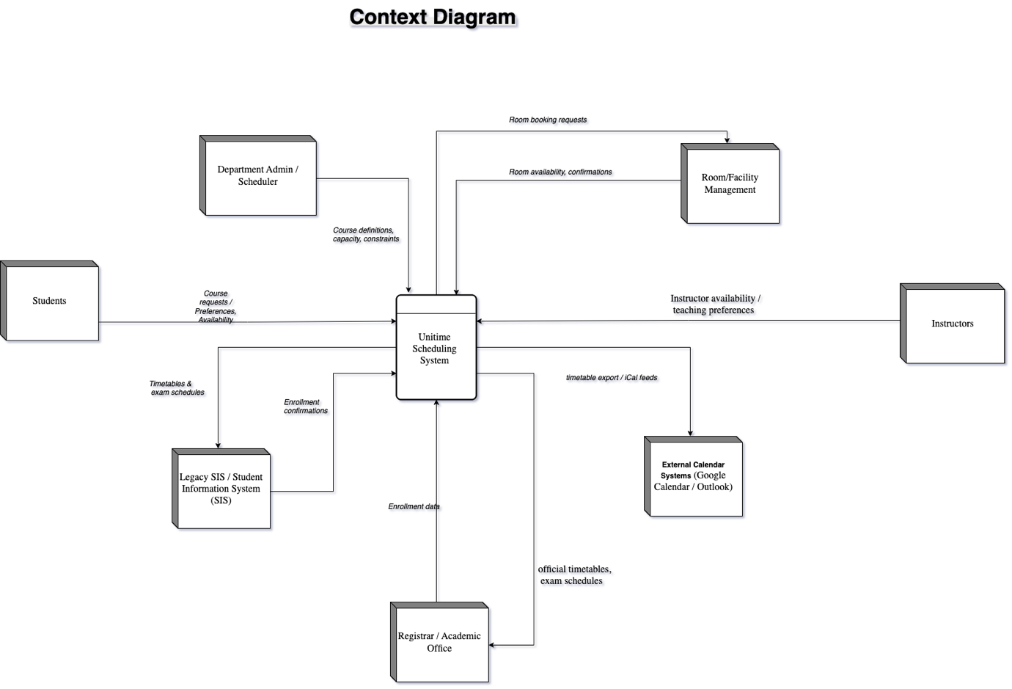

Data Flow Diagram
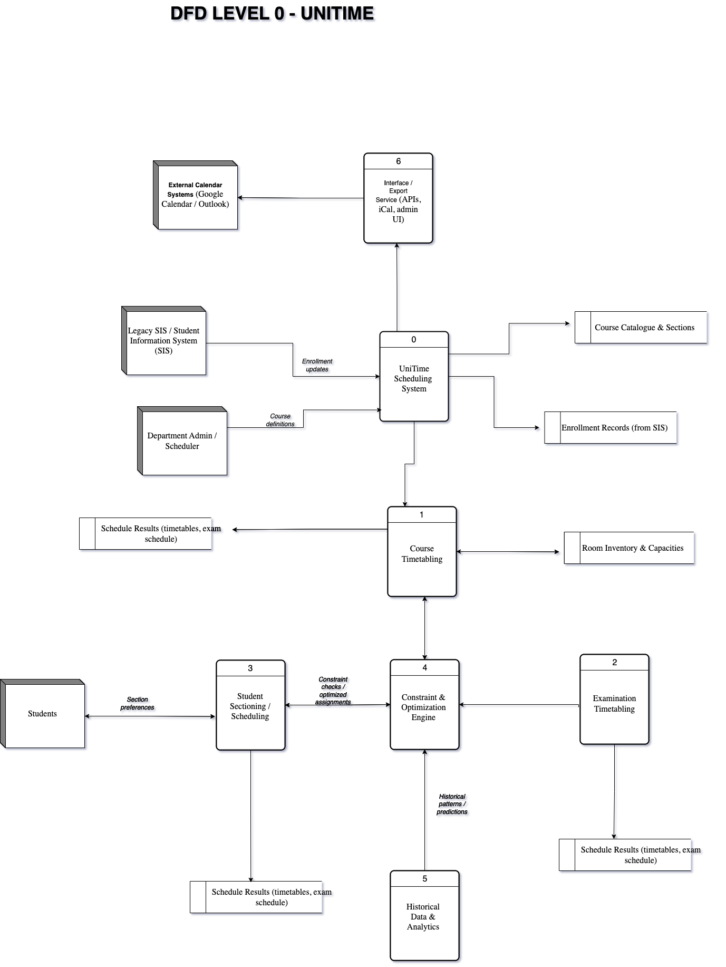

3.2 System 2 : Neural Network-Based University Course Timetabling System

3.2.1 Background/History
Neural network-based timetabling systems represent a cutting-edge research direction in educational scheduling. These systems leverage Artificial Neural Networks (ANNs) to learn complex patterns and dependencies between timetable entities (courses, rooms, instructors) from historical data and then use this learning to optimize future scheduling decisions. Their development is driven by the need to address the nonlinearities and vast number of constraints found in real-world university timetable problems, which can overwhelm classical algorithmic approaches(Ceschia et al., 2023). Neural networks, particularly Hopfield networks and later deep learning architectures were investigated for their potential to solve the University Course Timetabling Problem (UCTP), a well-known NP-hard challenge.
These systems represent a shift from rigid, rule-based scheduling toward data-driven optimization, enabling the timetabling engine to recognize constraint patterns and adaptively refine scheduling decisions.

How They Operate
  - Representation of Timetabling as a Neural Optimization Problem
- Encodes courses, rooms, timeslots, and constraints into nodes and connections of artificial neural networks (ANNs), enabling the model to process scheduling as a network optimization.
- Hard constraints (e.g., no conflicts between courses, staff availability) and soft constraints (e.g., preferred timing, room preferences) are converted into energy or penalty functions within the network.
- The system minimizes its global energy state, with stable low-energy configurations representing valid and optimized timetables
  - ANN Training Module (Pattern Learning)
- Artificial neural networks are trained on historical scheduling cycles, learning patterns and dependencies across course arrangements, resource allocation, and typical conflicts.
- Learning enables the network to predict optimal assignments, anticipating bottlenecks and minimizing clashes based on institutional scheduling trends.
- This module improves the efficiency of schedule generation over successive terms by updating model weights with new observed data
  - Constraint Handling & Optimization
- Hard constraints are encoded as large-weight penalties within the network to strictly avoid violations, ensuring feasibility.
- Soft constraints use adjustable preference weights, allowing flexible prioritization based on institutional policies or user preferences.
- The neural network performs constraint-aware learning rather than relying on classical, rule-based enforcement, improving adaptability to complex, nonlinear constraint spaces.
  - Automated Schedule Generation and Refinement
- Once trained, the neural system automatically generates candidate timetables by iteratively updating node activations to reduce constraint violations.
- Generated schedules undergo refinement cycles, incorporating feedback from conflict detection and user inputs for continuous improvement.
- This automatic process significantly reduces manual scheduling effort and runtime compared to traditional methods.
  - Integration and Real-Time Updates
- Real-time synchronization enables the timetable to adapt dynamically to changes in course offerings, lecturer availability, or room assignments.
- Feedback loops support continuous schedule adjustment and conflict resolution during the academic term.
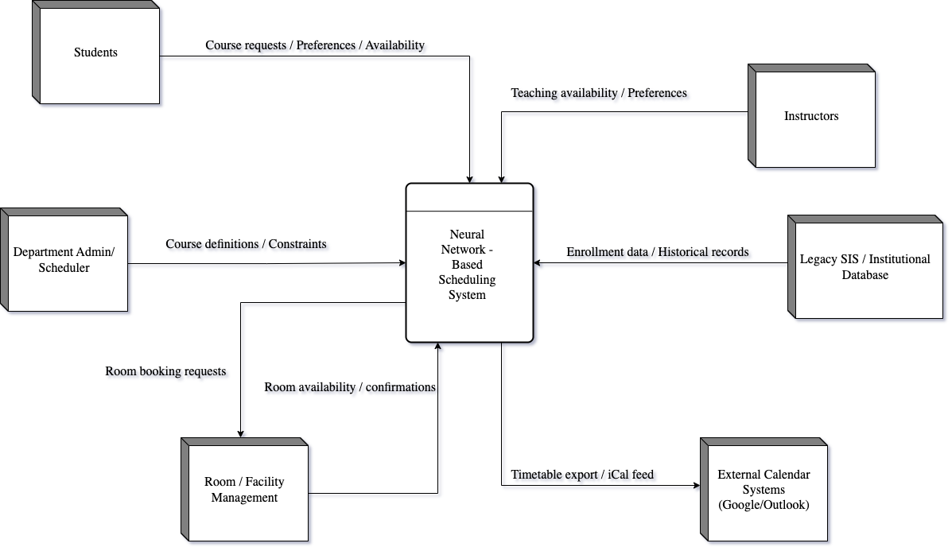
Context Diagram

Data Flow Diagram
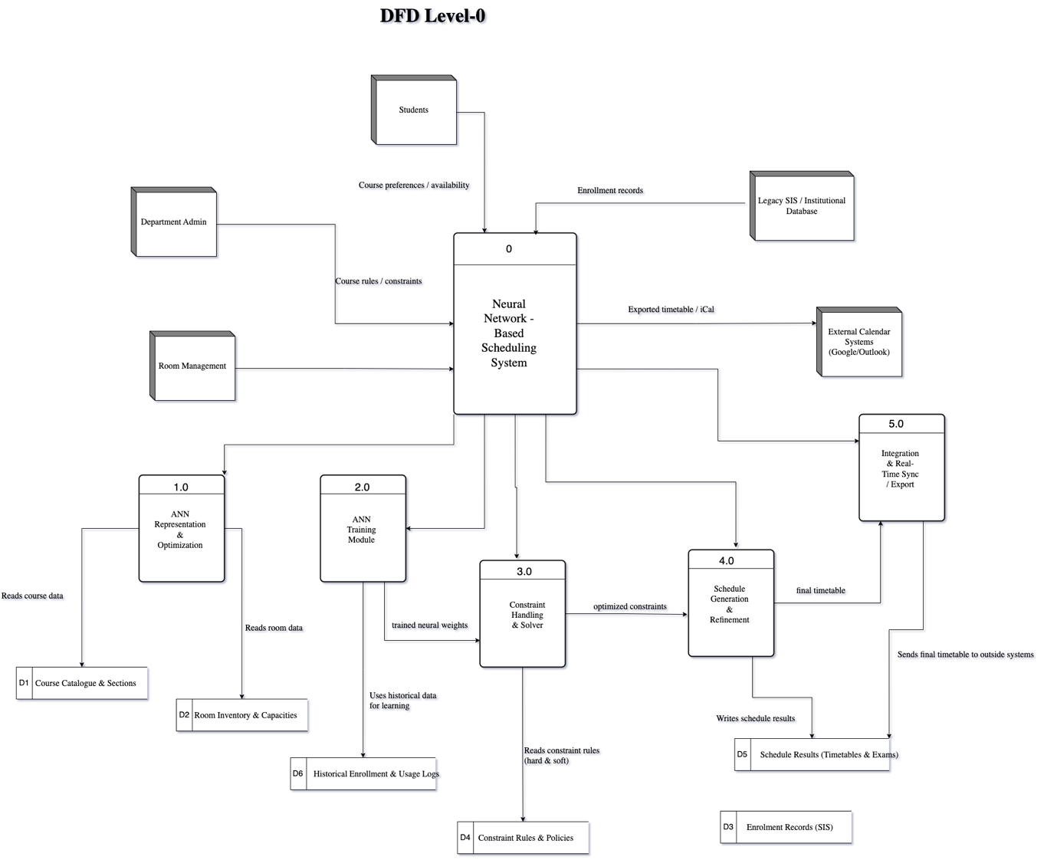

Strengths / Advantages
- Adaptive Learning Ability
Neural networks improve performance over time by adjusting weights based on historical conflict patterns, unlike fixed-rule systems.
- Effective Handling of Non-Linear Constraints
Neural networks naturally model complex, interdependent relationships, making them suitable for UCTP’s non-linear constraint landscape (Burke & Petrovic, 2002).
- Quick Approximate Solutions
Once trained, neural networks can produce feasible schedules much faster than classical combinational optimization methods.
- Self-Optimization Behavior
The minimization of an energy function allows automatic conflict resolution without manual intervention.
- Scalable Learning Framework
The architecture can be extended with additional layers to incorporate new features such as student preferences, instructor preferences, or real-time changes.
- Potential for Deep Learning Integration
Modern neural models (e.g., LSTMs, GNNs) can further improve predictive accuracy and constraint modeling when sufficient data is available.

Weaknesses / Disadvantages
- High Data Requirements
Neural network–based systems require significant historical data for effective training. Institutions with limited datasets experience poorer accuracy.
- Lack of Interpretability
Neural networks operate as “black boxes,” making it difficult for administrators to understand why particular scheduling decisions were made.
- Risk of Local Minima
Hopfield networks can converge to non-optimal local minima, producing suboptimal schedules unless carefully tuned.
- Complex Configuration and Training
Training neural networks requires expertise in AI and optimization, creating barriers for non-technical administrators.
- Computationally Intensive During Training
Initial training requires high processing power, limiting deployment in resource-constrained institutions.
- Difficulty Handling Hard Constraints Rigidly
Neural networks naturally approximate solutions—which may result in valid-looking but technically invalid timetables if hard constraints are not encoded properly.

Chapter 4: Analysis of the Proposed System

4.0 Overview of the Proposed System
The AI-powered scheduling system integrates institutional timetabling with personal time management into a unified platform (Ghiani & Ronzino, 2021). The system addresses scheduling challenges faced by educational institutions while simultaneously supporting individual productivity needs (Agarwal & Mehta, 2023). Personal schedules are derived from institutional timetables, with user-defined tasks and preferences layered upon institutional commitments to create comprehensive individual schedules (Gayathri & Easwaramoorthy, 2024).

Functional Requirements
1. Input Requirements
Institutional Data Inputs:
Input Category | Description
Course Specifications | Course codes, titles, credit hours, delivery modes, enrollment capacity (Ghiani & Ronzino, 2021)
Resource Inventory | Classrooms, laboratories, equipment with capacity and location details (Burke & Petrovic, 2022)
Constraints | Hard constraints (room capacity, resource availability) and soft constraints (preferred time slots, instructor preferences) (Okagbue & Adamu, 2023)
Faculty Availability | Teaching schedules, research commitments, preferred times, unavailable periods (Hartono & Hashimoto, 2023)
Student Data | Course registrations, curriculum requirements, prerequisites (Agarwal & Mehta, 2023)
Academic Calendar | Semester dates, examination periods, holidays (Burke & Petrovic, 2022)

Personal Data Input
Input Category | Description
User Profile | Role designation, institutional affiliation, scheduling preferences (Kumar & Mehta, 2023)
Tasks/Appointments | Task descriptions, durations, deadlines, priority levels, recurring patterns (Carvalho & Santos, 2023)
Personal Preferences | Preferred working times, productivity patterns, break preferences (Rahman & Khan, 2022)
Integration Preferences | Conflict resolution strategies, notification preferences (Gayathri & Easwaramoorthy, 2024)
Historical Data | Past scheduling patterns and outcomes for learning (Feng et al., 2022)

2. Processing Requirements

Schedule Generation and Optimization:
The system executes constraint satisfaction algorithms to generate conflict-free institutional timetables (Okagbue & Adamu, 2023). Neural networks identify successful allocation patterns from historical data (Hartono & Hashimoto, 2023), while reinforcement learning continuously improves scheduling decisions based on feedback (Feng et al., 2022). Genetic algorithms refine schedules to balance competing objectives (Kefalas & Fytas, 2019).

Pattern Recognition and Prediction:
The system analyzes historical data to identify recurring scheduling patterns and predict resource requirements (Hartono & Hashimoto, 2023). Individual productivity patterns—including peak performance times and optimal task sequencing—are recognized to enhance personalization (Kumar & Mehta, 2023).

Adaptive Learning:
The system extracts insights from scheduling history, adapts recommendations based on user feedback, and develops individualized scheduling models capturing unique user patterns and preferences (Rahman & Khan, 2022).

Integration and Reconciliation:
Institutional and personal scheduling constraints are reconciled by identifying conflicts and proposing resolution strategies (Gayathri & Easwaramoorthy, 2024). Bidirectional constraint propagation ensures coherent schedules across both domains (Ghiani & Ronzino, 2021).

Output Requirements

Institution Output
Output Type | Description
Institutional Timetables | Course-to-time-slot assignments, room allocations, resource assignments (Ghiani & Ronzino, 2021)
Faculty Schedules | Assigned courses, time slots, resources, conflict indicators (Burke & Petrovic, 2022)
Student Schedules | Enrolled courses, meeting times, instructors, room locations (Agarwal & Mehta, 2023)
Utilization Reports | Resource allocation patterns, utilization rates, availability (Hartono & Hashimoto, 2023)
Administrative Dashboards | Scheduling metrics, constraint satisfaction rates (Burke & Petrovic, 2022)

Non-functional Requirements

Table 1
Requirement | Description
Usability | Intuitive interfaces with minimal training requirements; role-specific variants; context-sensitive guidance (Nielsen, 2024)
Scalability | Maintains performance across institutional sizes from hundreds to tens of thousands of students; supports horizontal scaling (Agarwal & Mehta, 2023)
Security | Authentication and role-based access control; data encryption in transit and at rest; detailed audit logs (Viva Technology, 2025)
Performance | Institutional timetables generated within hours; personal optimization responds within seconds; graceful degradation under load (Ghiani & Ronzino, 2021)
Reliability | 99% availability during operational hours; automatic recovery mechanisms; data consistency maintenance (Burke & Petrovic, 2022)
Privacy | Compliance with data protection regulations; user control over personal data; minimized data collection (ShareArchiver, 2023)
Adaptability | Flexible algorithm configuration; supports different constraint sets; incorporates user feedback (Feng et al., 2022)

4.1 Major Features and Components of the Proposed System
The system comprises nine interconnected components delivering integrated scheduling capabilities (Ghiani & Ronzino, 2021).

Core System Components

1. Institutional Timetable Generation Engine
Generates optimized timetables by assigning courses to time slots and rooms while satisfying constraints and optimizing resource utilization (Okagbue & Adamu, 2023). Uses constraint satisfaction algorithms enhanced with machine learning for conflict-free schedule generation (Hartono & Hashimoto, 2023).

2. Personal Schedule Generator and Optimizer
Creates personalized schedules by integrating institutional timetable information with user-defined personal commitments, preferences, and priorities (Gayathri & Easwaramoorthy, 2024). Uses individual-specific optimization models trained on historical data (Rahman & Khan, 2022).

3. Pattern Recognition and Prediction Module
Employs neural networks for pattern extraction and reinforcement learning for outcome prediction (Hartono & Hashimoto, 2023). Identifies institutional scheduling patterns and individual productivity patterns to provide predictions about schedule effectiveness (Feng et al., 2022).

4. Constraint Management System
Maintains repositories of hard constraints (non-negotiable requirements) and soft constraints (preferences) (Okagbue & Adamu, 2023). Provides constraint validation and tracks satisfaction in generated schedules (GeeksforGeeks, 2023).

5. Integration and Reconciliation Engine
Manages integration between institutional and personal scheduling domains by reconciling constraints, identifying conflicts, and managing bidirectional constraint propagation (Gayathri & Easwaramoorthy, 2024).

6. Data Management and Analytics System
Manages scheduling information, user data, and historical data with appropriate security and access controls (Burke & Petrovic, 2022). Generates analytics reports on system performance and schedule quality (Agarwal & Mehta, 2023).

7. User Interface and Interaction Layer
Provides role-specific interfaces for administrators, faculty, students, and individual users supporting both automated recommendations and manual control (Nielsen, 2024).

8. Communication and Notification System
Delivers notifications through appropriate channels, respecting user preferences regarding timing and frequency (Kumar & Mehta, 2023). Includes reminder functionality for upcoming commitments (Carvalho & Santos, 2023).

9. Machine Learning Training Module
Trains and maintains machine learning models, performs scheduled neural network training, and implements reinforcement learning algorithms that improve based on feedback (Hartono & Hashimoto, 2023).
Integration Architecture
Components work through well-defined interfaces: the timetable generation engine feeds the integration engine; the pattern recognition module analyzes outputs from both institutional and personal schedule optimization; user feedback flows to the machine learning module; historical data enables continuous learning (Ghiani & Ronzino, 2021).

4.2 Benefits and Advantages of the Proposed System
The proposed system offers significant advantages over existing approaches, delivering benefits to institutional stakeholders, individual users, and organizational objectives.

Administrative Efficiency Improvements

Benefit | Impact
Reduced Workload | Timetable assembly reduced from weeks to hours; automated conflict detection eliminates manual verification (Burke & Petrovic, 2022)
Faster Adjustments | Rapid schedule regeneration when circumstances change (faculty illness, room unavailability) (Feng et al., 2022)
Improved Constraint Satisfaction | Higher rates of hard constraint satisfaction; weighted soft constraints reflecting institutional priorities (Okagbue & Adamu, 2023)
Resource Optimization

Benefit | Impact
Increased Utilization | Reduced gaps between classes; better room-to-enrollment matching (Hartono & Hashimoto, 2023)
Reduced Conflicts | Automated detection eliminates double-booking; proactive problem-solving (Okagbue & Adamu, 2023)
Dynamic Allocation | Machine learning predicts future resource needs; anticipates seasonal variations (Rahman & Khan, 2022)

Scheduling Quality

Benefit | Impact
Minimized Conflicts | Systematic constraint satisfaction virtually eliminates conflicts compared to manual processes (Ghiani & Ronzino, 2021)
Balanced Workloads | Equitable teaching load distribution across faculty (Burke & Petrovic, 2022)
Optimized Sequencing | Clustered related courses; minimized temporal gaps for students and faculty (Kumar & Mehta, 2023)

Personal Productivity and User Satisfaction

Benefit | Impact
Automated Integration | Personal schedules automatically incorporate institutional commitments; eliminates redundant data entry (Gayathri & Easwaramoorthy, 2024)
Personalized Recommendations | Machine learning generates context-specific scheduling recommendations based on individual patterns (Kumar & Mehta, 2023)
Reduced Cognitive Load | Automated routine tasks free mental resources for higher-value activities (Carvalho & Santos, 2023)

Comparative Adavantages

Compared To | Advantages
Manual Scheduling | Automates routine tasks; eliminates human error; reduces time from weeks to hours; provides analytics
Basic Computerized Systems | Incorporates machine learning; generates higher-quality schedules; integrates institutional and personal scheduling (Agarwal & Mehta, 2023)
Advanced Systems (UniTime) | More sophisticated ML approaches; explicit personal scheduling integration; individual productivity pattern recognition

4.3 System Context Diagram of the Proposed System
The system context diagram illustrates the proposed system's boundaries, identifies external entities that interact with it, and depicts major data flows and interactions.
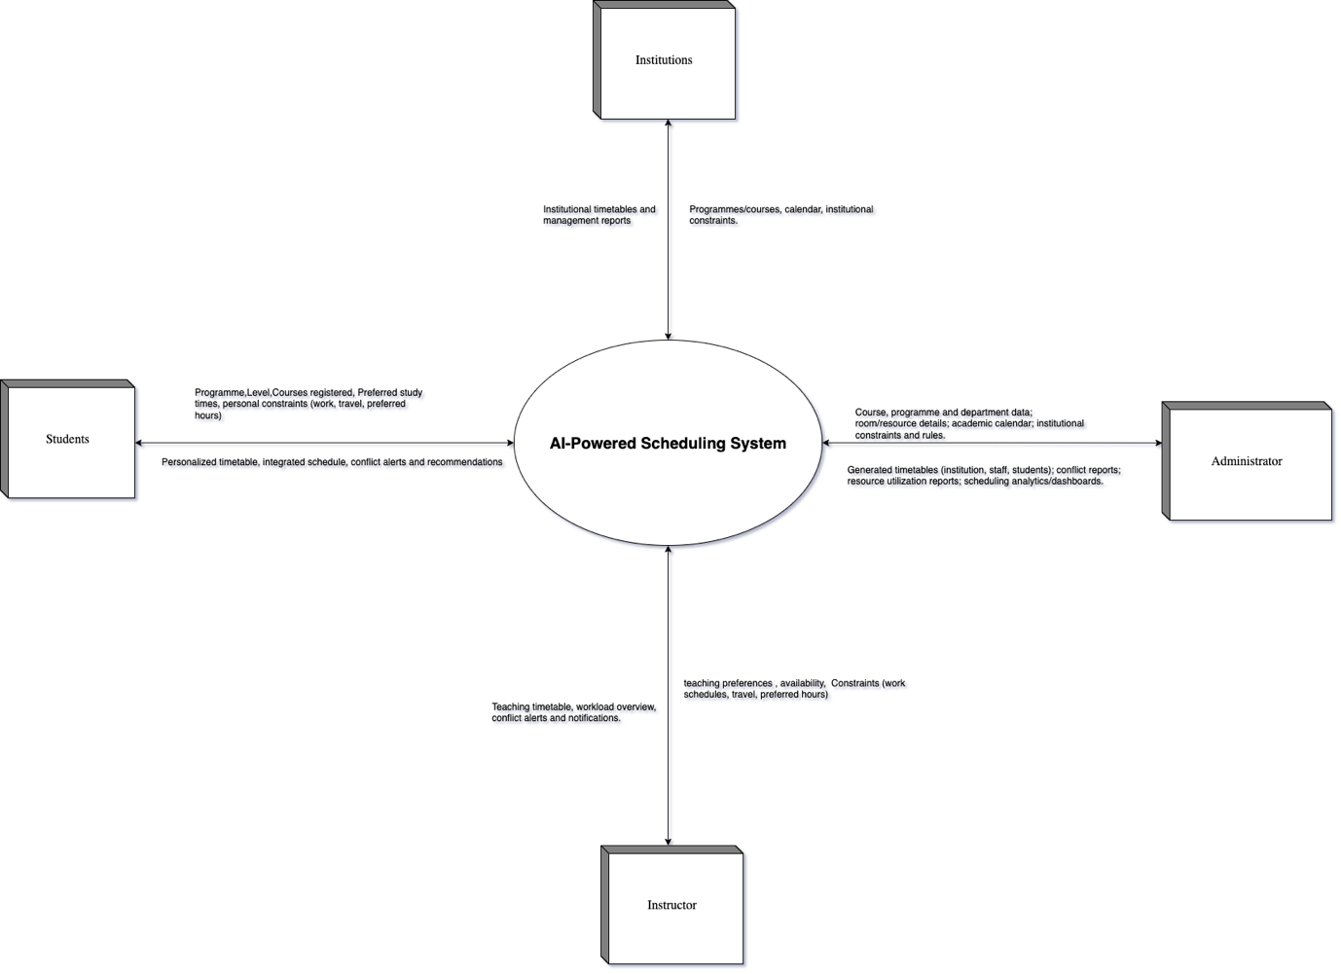

System Interactions
Inputs: Institutional Administration provides course specifications, resource inventory, constraint specifications, feedback, and policy adjustments. Faculty/Instructor provide teaching schedules, availability, preferences, and feedback. Students provide course registered, preferred study and constraints. Individual users provide personal task and appointment information, preferences, priorities, and feedback.
Outputs: Institutional timetables, faculty teaching schedules, student course schedules, personalized individual timetables, resource utilization reports, conflict reports, and
administrative dashboards.

References
Abdipoor, S., Yaakob, R., Goh, S. L., & Abdullah, S. (2023). Meta-heuristic approaches for the University Course Timetabling Problem. Intelligent Systems with Applications, 19. https://doi.org/10.1016/j.iswa.2023.200253
Agarwal, P., & Mehta, S. (2023). Revolutionizing education management: A comprehensive review of AI-driven scheduling systems. International Journal of Educational Technology, 15(3), 145-162.
Anderson, P., Chen, Y. (2023). Enterprise calendar systems: Integration, synchronization, and organizational workflow optimization. Information Management & Computer Security, 29(4), 312-328.
Bennett, S., & Morrison, K. (2023). Microsoft 365 scheduling integration: Enterprise productivity enhancement through automation. Journal of Information Systems Management, 31(2), 74-89.
Bismaya, P., , D. D., & , A. P. K. B. (2025). Analyzing The Effectiveness of School Timetable on The
Holistic Development of Secondary School Students in
Khordha. INTERNATIONAL JOURNAL OF INNOVATIVE RESEARCH IN TECHNOLOGY 11(8).
Burke, E. K., & Petrovic, S. (2022). Recent advances in automated academic timetabling. European Journal of Operational Research, 267(1), 1-15.
Carvalho, M., & Santos, M. Y. . (2023). Time management applications and productivity: A systematic literature review. International Journal of Human-Computer Studies, 169, Article 102956.
Ceschia, S., Di Gaspero, L., & Schaerf, A. (2023). Educational timetabling: Problems, benchmarks, and state-of-the-art results. European Journal of Operational Research, 308(1), 1-18. https://doi.org/10.1016/j.ejor.2022.07.011
Davis, R., Park, J. (2023). Asana for team project management: Feature analysis, user adoption, and organizational productivity impact. Journal of Management Information Systems, 39(4), 287-312.
Feng, Y., Wang, D., & Li, J. (2022). Reinforcement learning for dynamic timetable generation: A case study in higher education. IEEE Transactions on Learning Technologies, 15(3), 298-311.
Garcia, R. S., M. (2023). Any.do: Consolidating task management and calendar planning in unified productivity platform. Journal of End User Computing Research, 15(1), 78-95.
Gayathri, K., & Easwaramoorthy, S. (2024). Integrating institutional and personal calendars: Challenges and solutions. Journal of Information Technology Education: Research, 23, 41-58.
Ghiani, G., Ronzino, A. . (2021). Operations research methods for educational timetabling: A systematic review. Computers & Operations Research, 128, 105-214.
Hartono, P., & Hashimoto, S. (2023). Neural networks for university course timetabling: A deep learning approach. Applied Intelligence, 53(1), 839-855.
Hassan M, A.-K. N. (2023). Educational timetabling systems: Design, implementation, and effectiveness in higher education. Computers & Education, 187, 104-121.
Kumar, A., & Mehta, R. (2023). AI-enabled personal assistants: Impact on individual productivity and time management. Journal of Management Information Systems, 40(1), 228-259.
Lawrence A. Farinola, M. B. M. A. (2025). Explicit Artificial Intelligence Timetable Generator for Colleges and Universities. Open Journal of Applied Sciences, 15. https://doi.org/10.4236/ojapps.2025.158151
Ng L, C. W., Lee, S. (2023). Celcat Timetabler: Features, deployment strategies, and effectiveness in higher education institutions. Journal of Educational Technology & Society, 26(3), 198-216.
Nsulangi, P. T., Ngongi, W. E., Likamba, M. R., Sarehe, O. B., & Mkwande, M. A. (2024). A Comparative Analysis of Manual and Automatic Timetabling Approaches for Resource Utilisation in Tertiary Higher Learning Institution. International Journal of Computer Science and Mobile Computing, 13(12), 65-76. https://doi.org/10.47760/ijcsmc.2024.v13i12.007
Okagbue, H. I., & Adamu, M. O. (2023). Mathematical modeling for educational timetabling: A review. Journal of Applied Mathematics and Computing, 71(1), 171-197.
Rahman, S. A., & Khan, Z. (2022). Personalized scheduling using reinforcement learning: Towards adaptive time management. IEEE Transactions on Neural Networks and Learning Systems, 33(11), 6172-6185.
Romero, M., & Valdivia, A. (2020). Collaborative scheduling in cloud ecosystems: Design patterns and implementation strategies. IEEE Transactions on Cloud Computing, 8(2), 45-62.
Smith B, J. K. (2023). Comprehensive timetabling solutions for educational institutions: Architecture, implementation, and organizational impact. International Journal of Educational Management, 37(2), 156-174.
Thompson, K. W., S. . (2023). Todoist and similar task management applications: Features, usability, and impact on individual productivity. Journal of Information Technology Education: Research, 22, 189-207.
UniTime. (2025, February,2025). Comprehensive University Timetabling System. https://www.unitime.org

